**Centos 7/ubuntu installation with VM:**

1. Download workstation/virtual box and install

-**VMware Workstation Pro 16.1.0 Build 117198959 incl keygen [CrackingPatching]**

1. Centos 7 iso download (minimal version)

Link : <http://mirror.dhakacom.com/centos/7/isos/x86_64/>

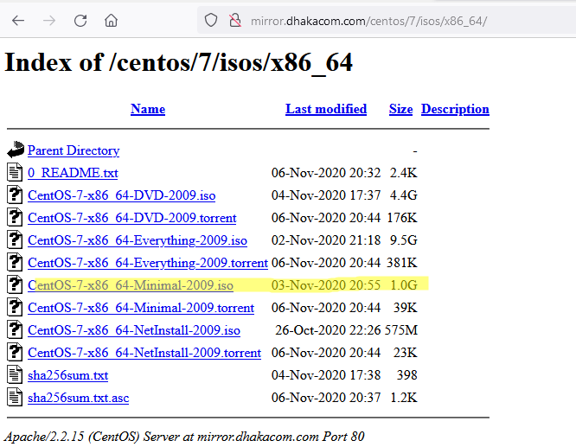

1. Open vmware workstation and click create new virtual machine and follow below steps:

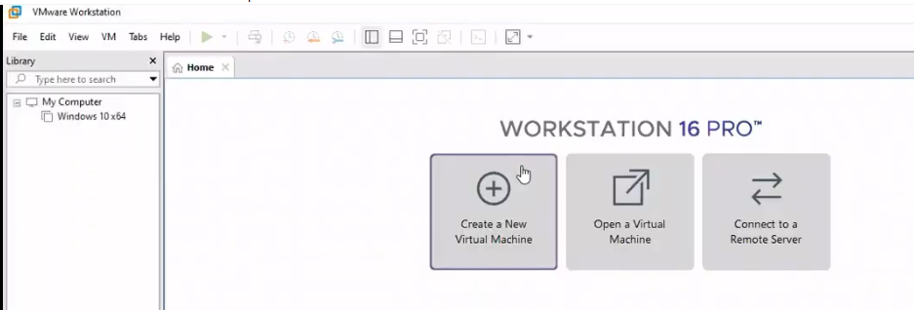

Select custom:

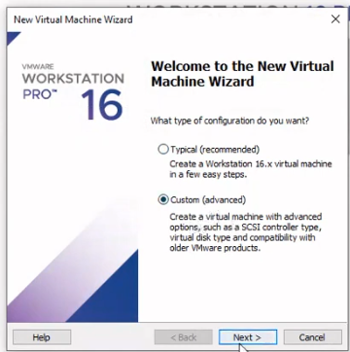

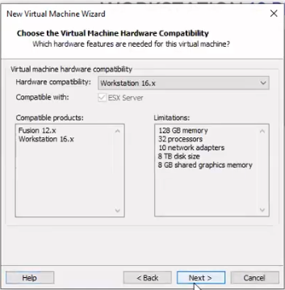

Select, I will install operating system later

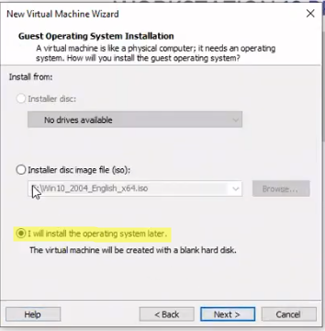

Choose operating system and version:

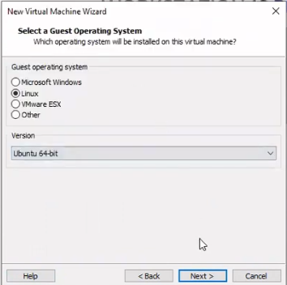

Select installation path:

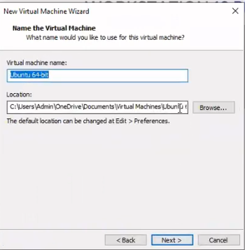

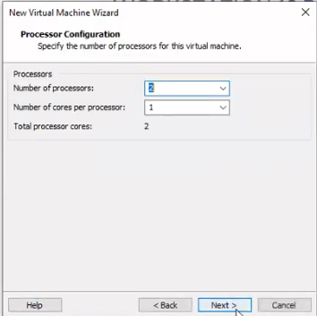

Select Allocate all disk space now

Store virtual disk as a single file

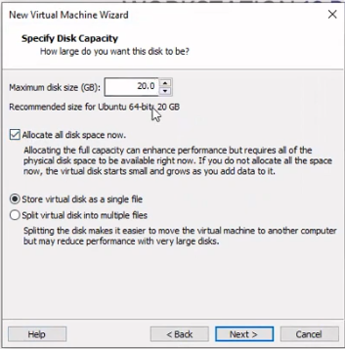

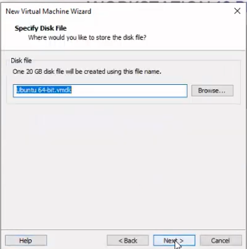

Press finish:

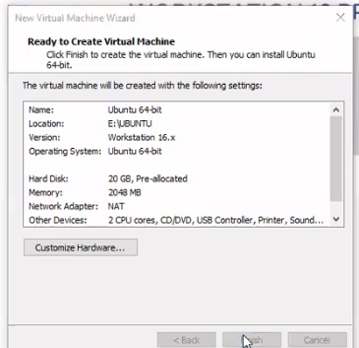

Now no need to power on, click on edit virtual machine settings and set iso file image path

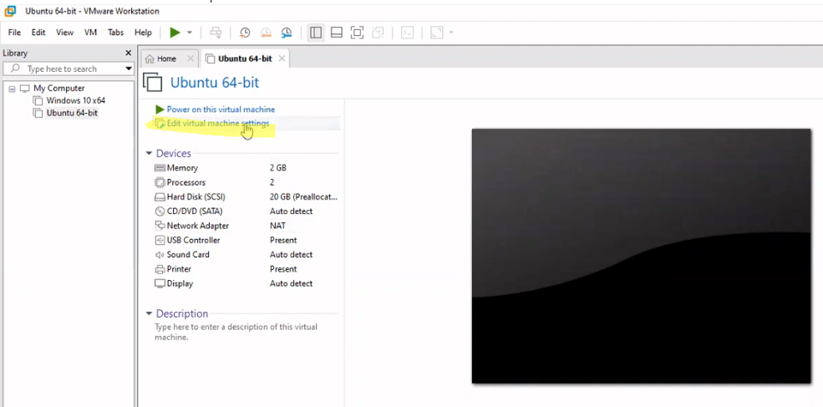

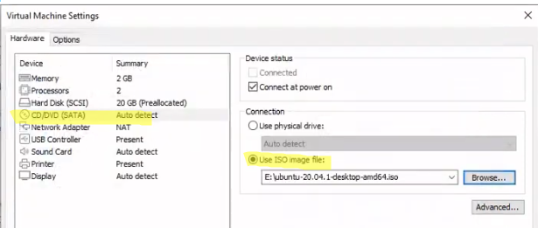

Press ok and then power on the virtual machine.

Installation will be begun accordingly